H.T No
Regulations:
A17

Sreenidhi Institute of Science and Technology
(An Autonomous Institution)
Code No: 6B412 Date: 03-Dec-2020 (FN)

B.Tech II-Year II-Semester External Examination, Nov/Dec - 2020 (Supplementary)
MACHINE DRAWING AND COMPUTER DRAWING (ME)

Time: 2 Hours Max.Marks:75

Note: a) No additional answer sheets will be provided.
b) All sub-parts of a question must be answered at one place only, otherwise it will not be valued.
c) Missing data can be assumed suitably.

ANSWER ALL TWO QUESTIONS.

1. | a) | Draw the half sectional view from the front, with top half in section and the view from the side of a cotter joint with socket and spigot ends, to connect two rods of 20 mm diameter each. Indicate dimensions in terms of diameter of rod “D”. | [30M]
 |  | (or)
 | b) | Draw (i) sectional view from the front and  (ii) view from above, of single riveted double strap butt joint, to join plates of thickness 10mm. Indicate dimensions in terms of diameter of rivet. | [30M]
2. |  | Assemble all parts of the spring loaded relief valve, given in the below figure and draw the (i) Sectional view from the front, and (ii) View from the right. | [45M]
 |  | 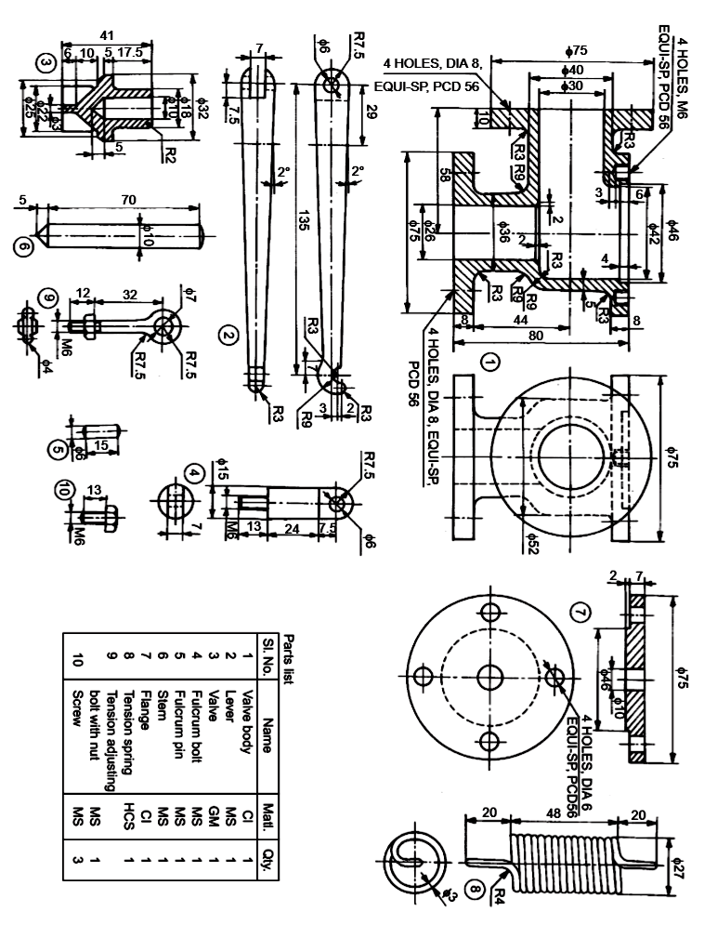

-- 00 -- 00 –

